2DX4: Digital Signals

Lab #1

Instructor: Drs. Bruce, Haddara, Hranilovic, and Shira

Lab TAs: Abdallah Ghazy

(TA MACID1), Tau Rasethuntsa

(TA MACID2)

Tianze Zhang L01 – zhant22

As a future member of the engineering profession, the student is responsible for performing he required work in an honest manner, without plagiarism and cheating. Submitting this work with my name and student number is a statement and understanding that this work is my own and adheres to the Academic Integrity Policy of McMaster University and the Code of Conduct of the Professional Engineers of Ontario. Submitted by [Tianze Zhang, zhant22, 400208135]

# Pre-Laboratory Preparation

2.machine language is the binary code that computer can understand, eg: 10011101,

OP code is the comment or order that give to the computer telling what to do next. Mnemonic is an abbreviation for an operation. it is usually a symbolic name for a single executable machine language instruction. Eg: “ADD” , “MUL”

3. blinkLED

<https://drive.google.com/file/d/1ecGjxBAtPB3qS9dsfDvENtv_rW9CnZ21/view?usp=sharing>

4.For MSP432E401Y board, the core processor used is ARM Cortex -M processor. The processor has 32-bit register in total: 13 general-purpose registers, r0-r12 ; Link Register (LR), r14, Program Counter (PC), r15, the rest of registers are special registers. The core processor is an 32-bit architecture, which means it can transfer 32-bit data per clock cycle.

5. The MSP432E401Y is a 32-bit Arm Cortex-M4F based microcontroller with 1024KB of flash memory,256KB of SRAM, 6KB of EEPROM, and 120-MHz operation, integrated 10/100 Ethernet MAC and PHY

6. MSP432E401Y SimpleLink Ethernet Microcontroller

7.

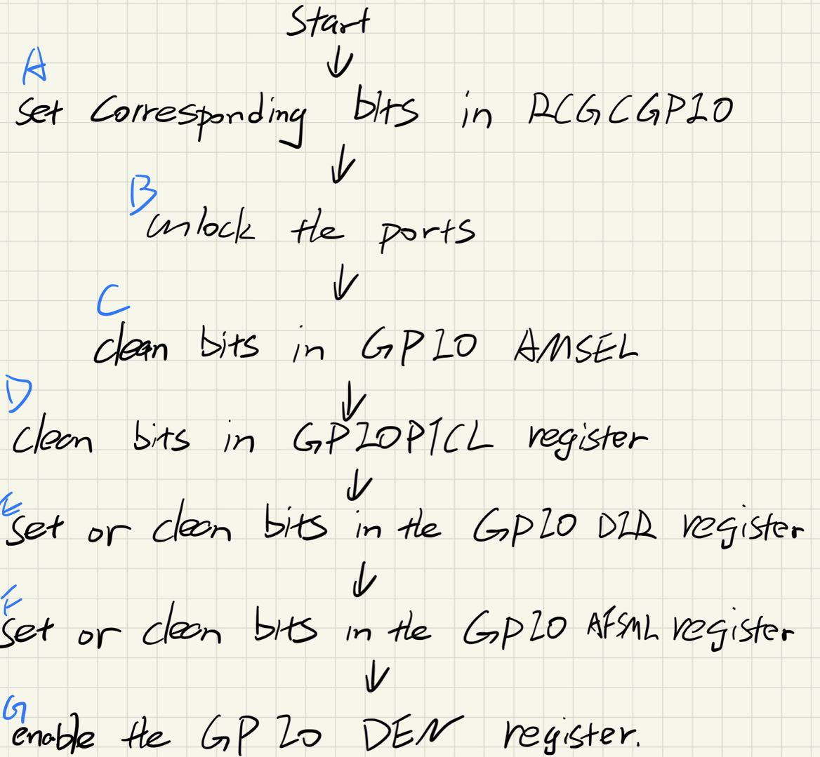

For step A, RCGCGPIO register sets the corresponding bit of register to 1 in order to activate the clock for certain port.

For step C, GPIO AMSEL set a pin as an analog input.

For step D, PTCLGPIO Clears the bits stored in the register, and then select regular digital function

Foe step E, GPIO DIR differentiate inputs pin and outputs pin.

Foe step F, AFSML disable the alternate function on the pin.

Foe step G,DEN set the pin into a digital input or output.

7.a) for port M, the base address is 0x40063000

GPIO Direction Register address: 0x40063400

GPIO Digital Enable register: 0x4006351C

GPIO Port M Data Register (All 8 bits access) =0x400633FC

7.b)for port N, address is 0x40064000.

GPIO Direction Register address: 0x40064400

GPIO Digital Enable register: 0x4006451C

GPIO Port N Data Register (All 8 bits access) =0x400643FC